AWS Task-5

Deploy a simple web application using AWS CodeCommit, CodeBuild, and deploy & access it via a browser, and automate the process via CodePipeline.
Create a simple web page
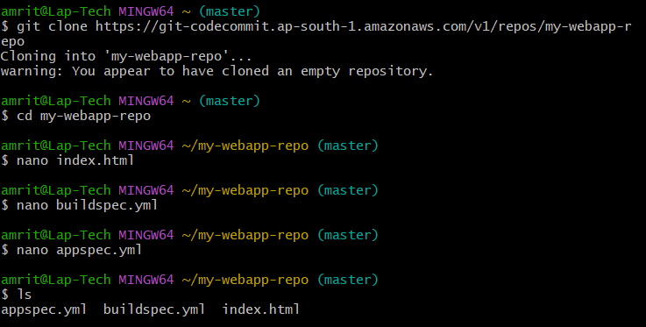
Push files on repo
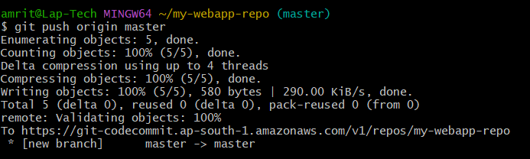

CodeCommit repo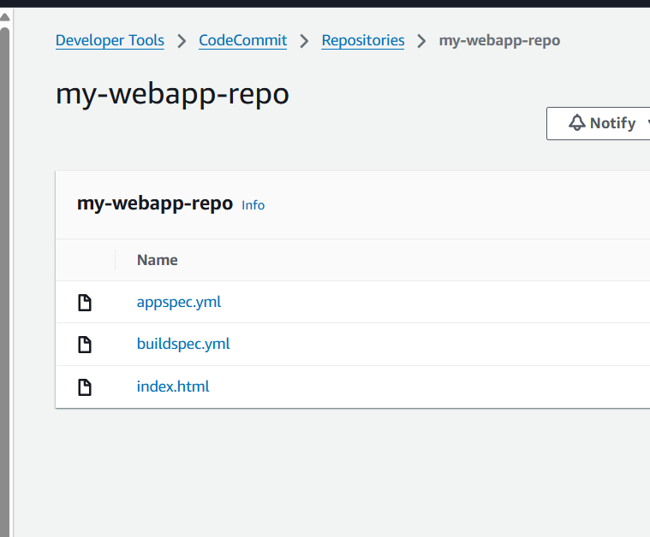

CodeBuild
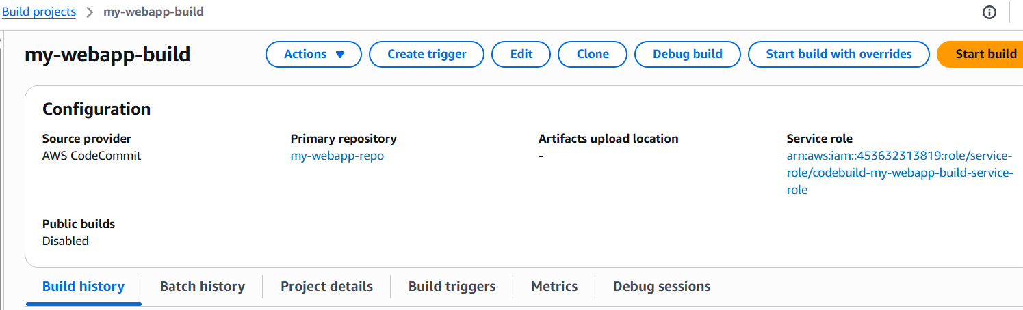

EC2 instance showing IAM Role attached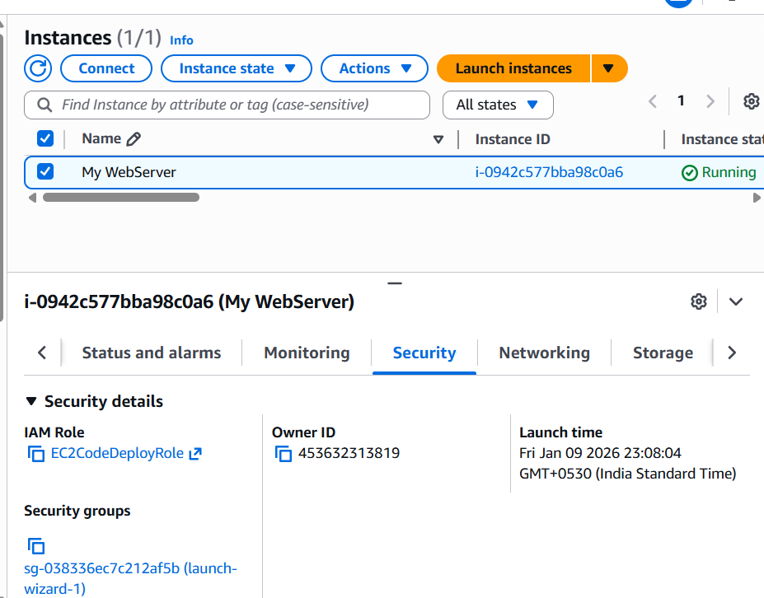

codedeploy-agent status
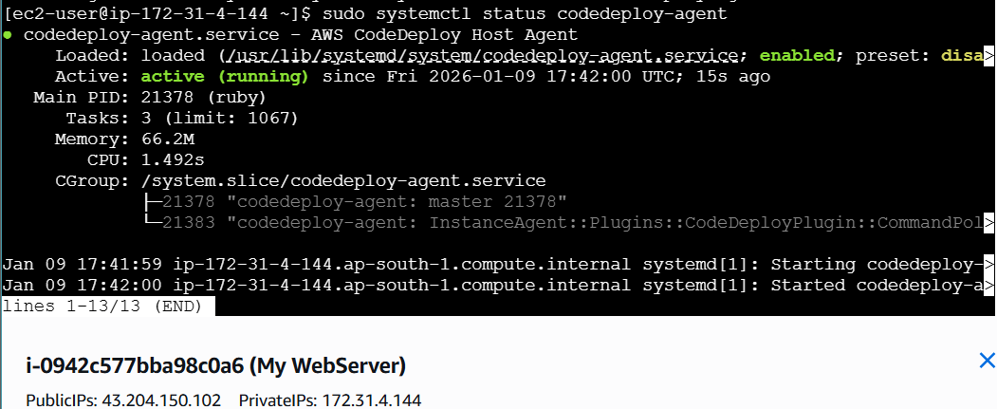

CodeDeploy Application page

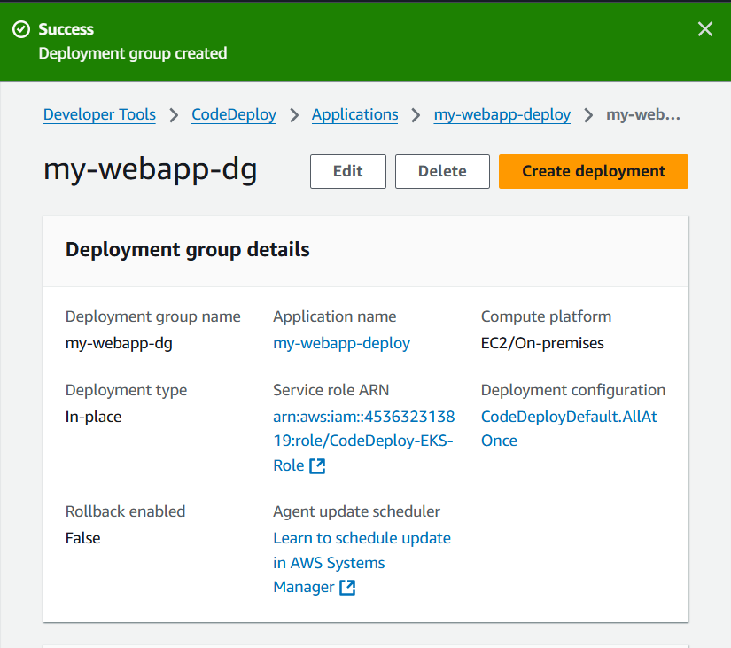

CodePipeline
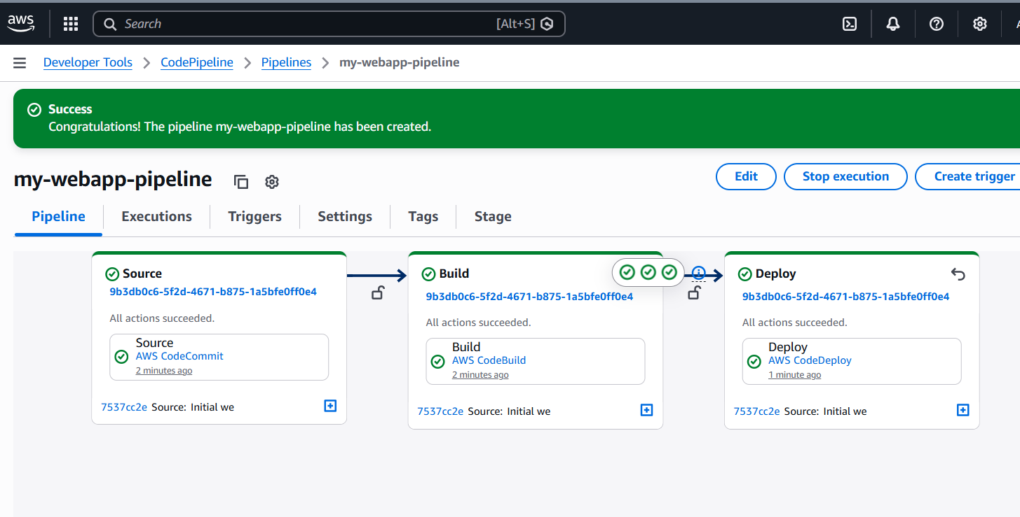

Browser output page
